**Scintillator Field**

**Elementary Particle Detector**

*DAWSON COLLEGE*

ENGINEERING TEAM PROJECT DETAILS

PROTOTYPE ENGINEERING DRAWING

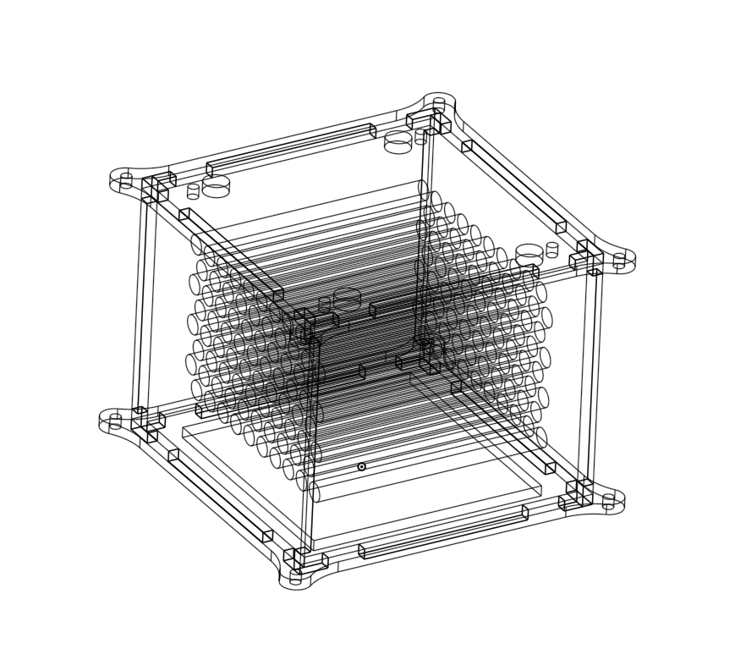

Contents

Project description 3

Current prototype 4

Teamwork, Communication and Diversity 5

Iterative Designs 7

Finances and Supplies 8

## Project description

We submit our project to the Beamline for Schools international competition at CERN. It is completed as a part of Dawson’s High Energy Particle Physics Club.

In order to concretize our design by means of effective teamwork, we have split the execution of our project into several sub-tasks. We have a hardware engineering team, a software team, a math pattern optimization team, a theoretical particle physics research team and a directing team.

1. The mathematics team has been working on the problem of optimizing rod placement for the highest accuracy on the greatest covered area. Further, they have been researching how to create a statistical field to determine particle position using concepts from linear algebra and Bayesian statistics.
2. The hardware team has come up with the concept of using scintillators with photomultipliers to detect muon position using a customized PCB system
3. The software team has been designing the system-workflow of the PCB's and the data analysis implementation of the statistical field that determines muon position.
4. The physics research team has concerned itself with verifying the feasibility of the endeavour and setting reasonable boundaries to expected particle position.
5. The directing team has done a wonderful job at coordinating everyone's work by keeping a general overview and ensuring everybody is on the same page.

## Current prototype

This is an example of the hardware team's first prototypes of a laser-cut acrylic case for our apparatus, along with aluminium supports. The goal of the case is to protect the internal system while allowing for very precise scintillator rod placements. The heatsinks of a high throughput cooling system required by our detector is shown (in black). This is only the support system for the actual detector rods, which we could not yet acquire. SAEF’s funding will support the purchase of the parts necessary to complete this machine.

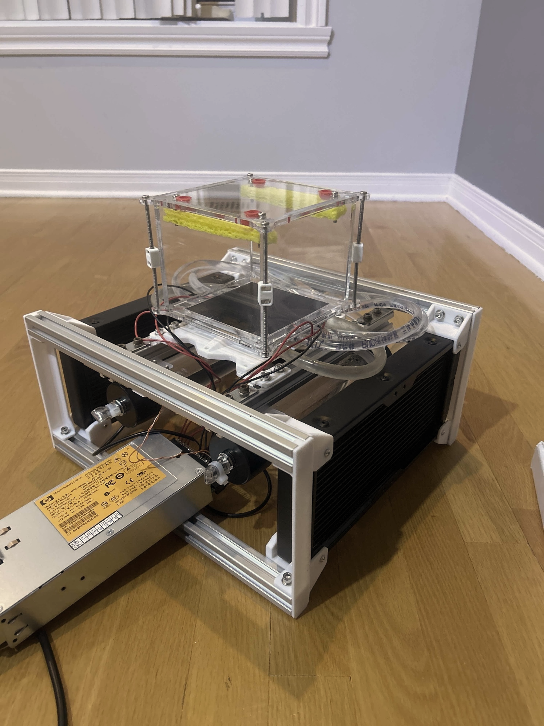

## Teamwork, Communication and Diversity

Here one of our members from the hardware team is designing a first computational model of the case that will be able to hold 3d printed parts that will keep the rods in place (left).

The lead of the mathematics team is explaining his simulation to someone from our hardware team so that the hardware team is aware of which rod arrangement models their case has to be able to hold (right).

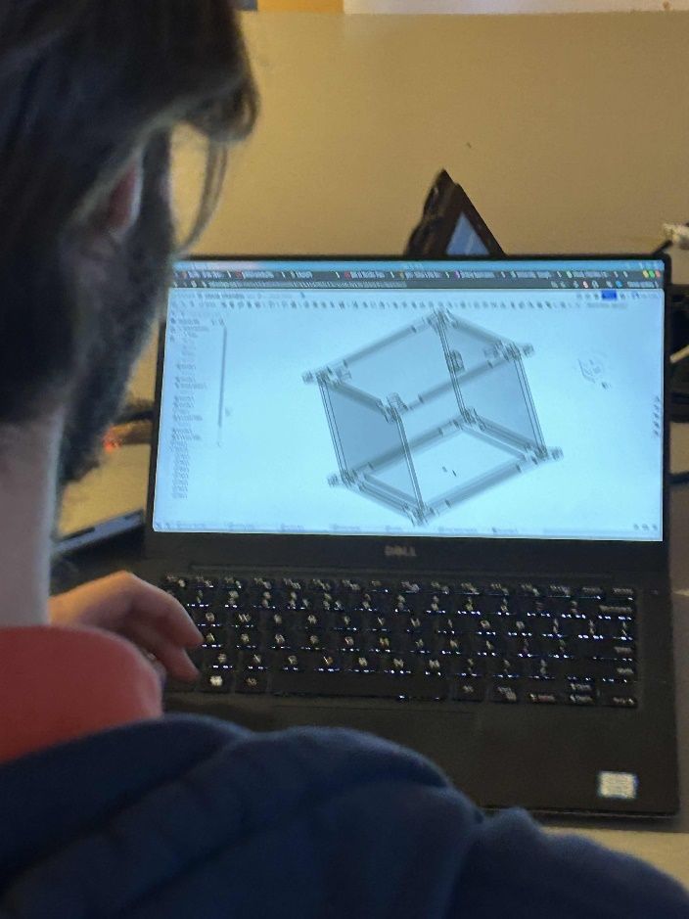 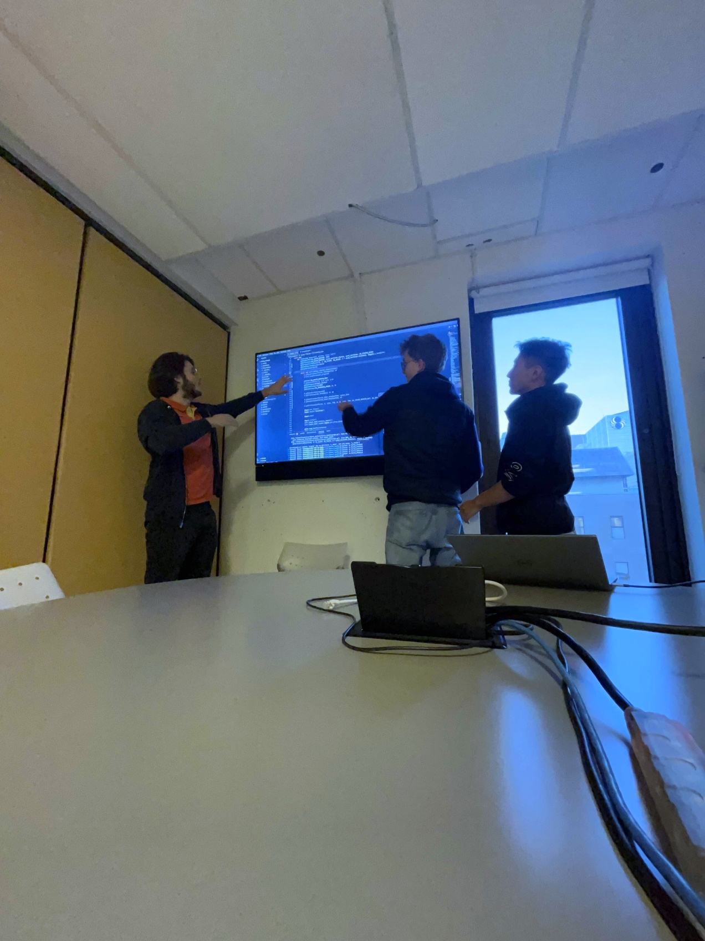

Here is an image of two the PCBs’ our software team has been getting acquainted with. They will implement their final code as soon as the mathematics team has chosen an optimal pattern and that the physics team approves the pattern as feasible with confirmation from our hardware teammates.

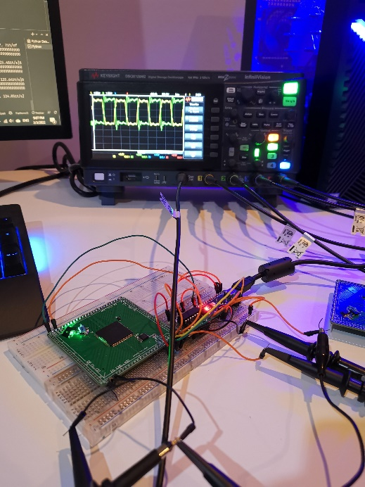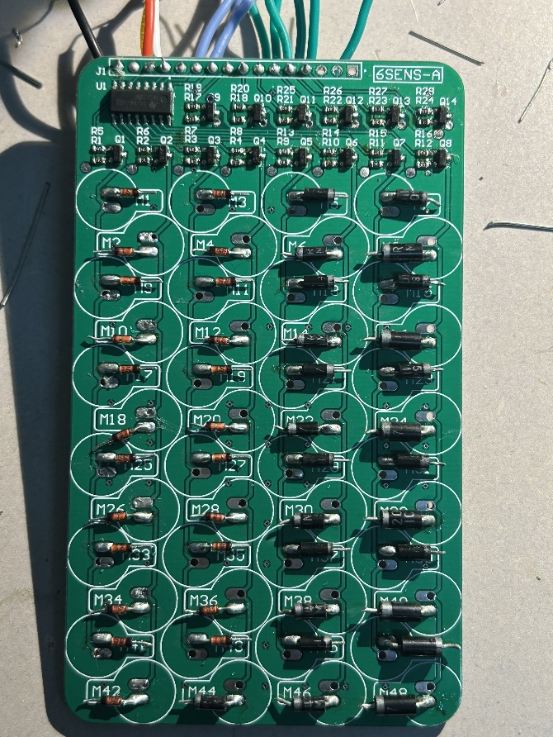

## Iterative Designs

Here is an image of the hardware team’s construction and engineering process to attain the cryogenic temperatures required for our detector’s functioning. The construction was done in steps to ensure each part works separately before integration: 3D printing, water-cooling and wiring. This consists of the support structures necessary for the rods – the rest of our approach – to work properly. Our hardware team is currently working on iterating on these designs, as well as modeling them before physical construction.

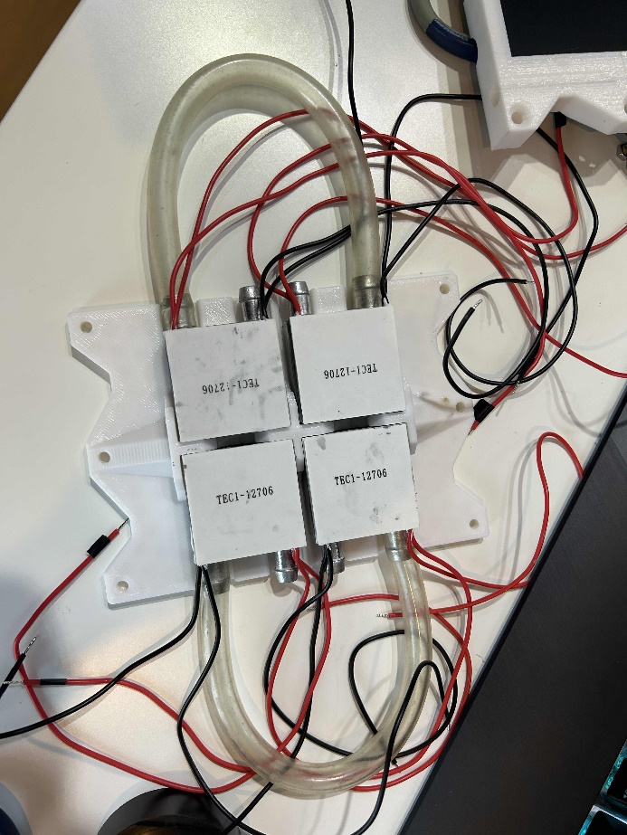 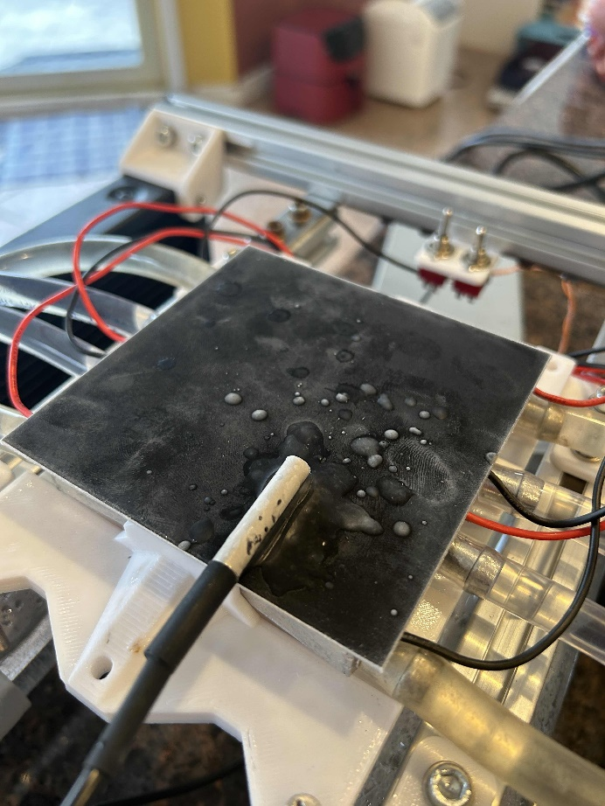

## Finances and Supplies

We detail the listed supplies in the “Projects Costs” section of the application here. These parts we could not yet purchase, but they are critical in the working of the detector.

*Plastic scintillator rods* 128 x 19.13 $ + tx = **2815.32 $**

5mm in diameter, 100mm in length: the scintillator rods emit light when a subatomic particle intersects its volume. This is a critical dependency in terms of supplies, as our particle detection approach relies on their properties.

Supplier: <https://eljentechnology.com/>

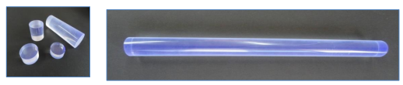

*Silicon photomultipliers* 128 x 22.44 $ + tx = **3302.45 $**

6mm by 6mm microchips: the silicon photomultipliers amplify the light emissions from the rods, and convert them into measurable electronic pulses.

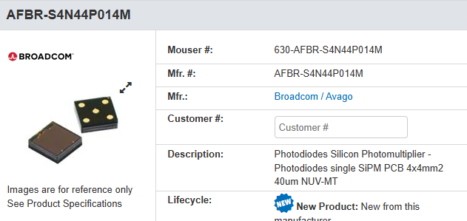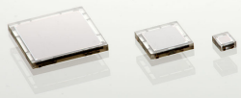

Supplier: <www.mouser.ca>

*Aluminium Extrusion Bars* 1 set for the case + tx = **22.97 $**

20mm by 20mm in cross-section aluminium bars for general support.

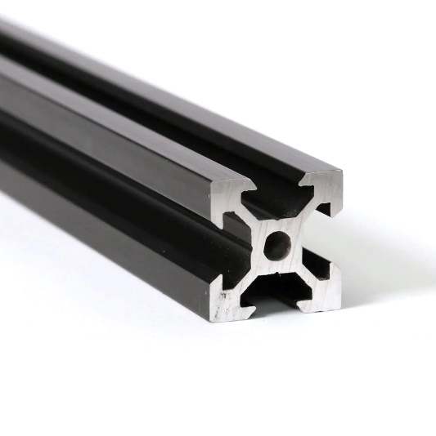

Supplier: <www.mcmaster.com>

*Printed Circuit Boards* 16 PCBs x 2.57$ + tx =**47,28 $**

*Electronic Components (miscellaneous)* **100 $**

The printed circuit board is the design of our hardware team, and the manufacturing will be done via an online service. They will reliably connect our electrical components, and make sure our detector functions properly. We allocate a budget of 100$ for the electric components since there are many contained within the parts list. Here’s an example of the PCB that will analyze the signals emitted by the silicon photomultipliers.

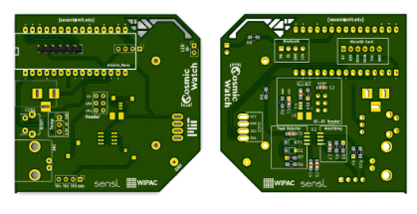

Supplier: <https://jlcpcb.com/>

*3D Printing Material* 2kg x 22.76$/kg + tx = **52.34 $**

Parts designed by our hardware team that need to be rapidly manufactured will be made in-house on 3D printers. Consequently, the rolls of PLA plastic required will be an expense. Our existing 3D printer that we will use for prototyping parts.

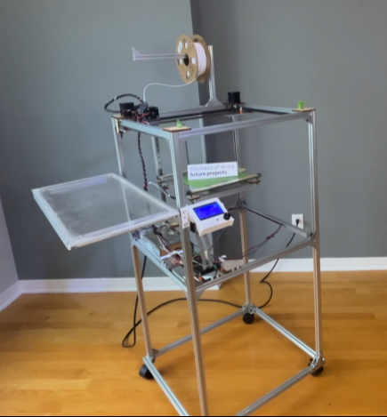

Supplier: <https://polymaker.com/>